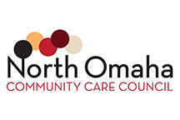

NOCCC Scholarship Program

Directions: This page must be completed by the financial aid officer at your respective university.

_$________________________________
Total Financial Aid Award Amount

_$___________________________________________________
Remaining Tuition Balance (After Financial Aid Applied)

_$________________________________
Expected Family Contribution (EFC)

Form Completed By (Print)

_______________________
Form Completed By (signature) Date

Title/department

___________________________
Email Phone (include area code)

Please complete this NOCCC Financial Need Form, provide a copy of current enrollment/registration, and return scanned copies via email or by postal mail to:

NORTH OMAHA COMMUNITY CARE COUNCIL
P.O. BOX 31341, OMAHA, NE 68132
EMAIL: MAIL@NORTHOMAHACCC.ORG

